Practical - 14
Practical Title: 14: Admin Dashboard with Role-Based Access Control, Dynamic Menu, and Audit Log

Problem Definition: Develop an admin dashboard that displays user statistics, student count,

event count and latest registrations. Restrict access to admin users only

and show dynamic menu options based on role.

Theory

1. Are dashboard values loaded dynamically from the database?
ANSWER: Yes, dashboard values are loaded dynamically from the MySQL database using PHP and SQL queries.

2. Is access restricted to admin users?
ANSWER: Yes, access to the admin dashboard is restricted to authenticated users with the admin role. PHP checks the user's role before allowing access to protected pages. Unauthorized users are denied access.

3. Are role-based menus working?
ANSWER: Yes, the dynamic menu retrieves menu items from the menu_items table according to the logged-in user's role. This allows different roles to see the menu options permitted for them.

4. Are important admin actions recorded in audit_logs?
ANSWER: Yes, important activities, such as login, logout, and dashboard access, are recorded in the audit_logs table with details and timestamps. Administrators can view these records to monitor system activity.

Implementation/ Output/Result:

Evidence of Work (Screenshots):

Admin Login page:
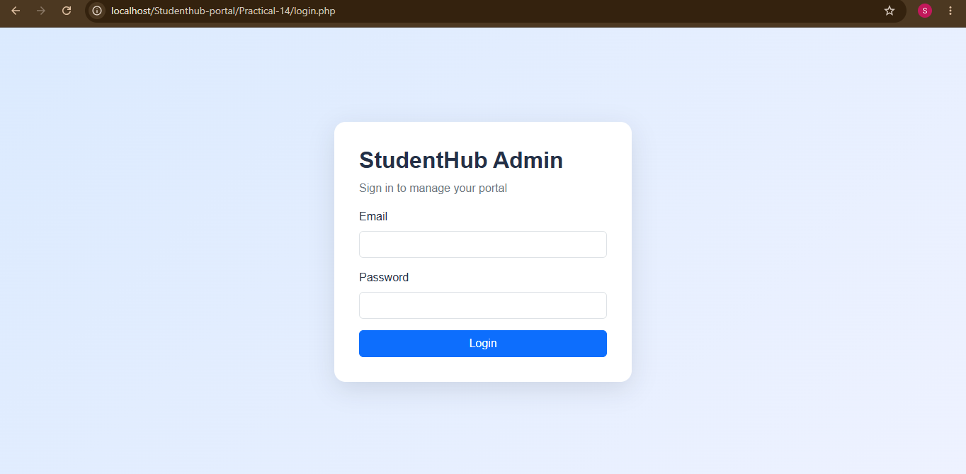

Entering credentials of admin:
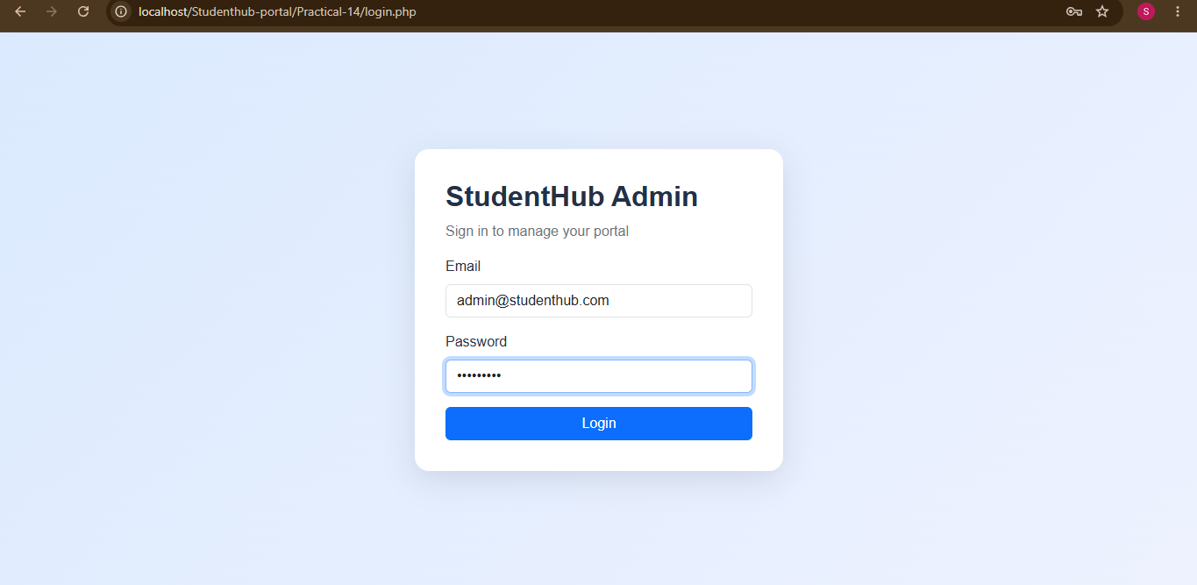

Admin Dashboard:
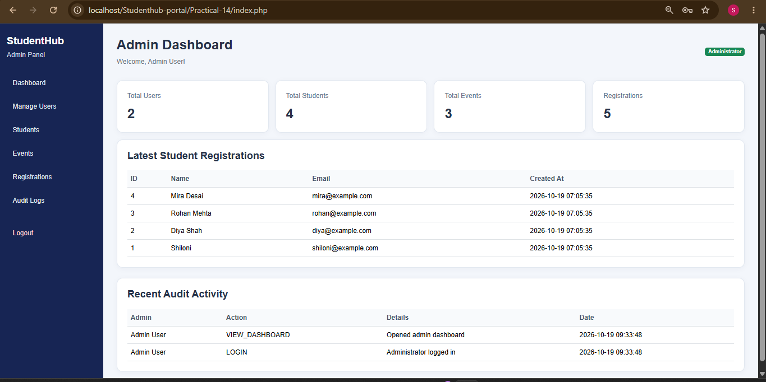

Student Records:
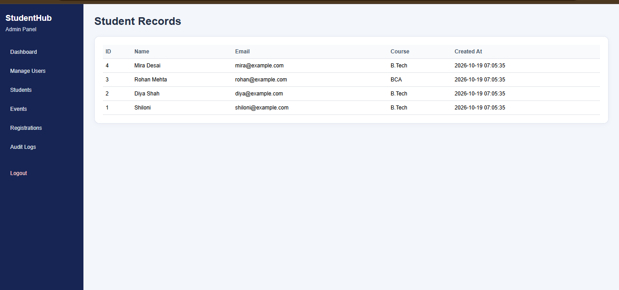

Event name and registration time period:
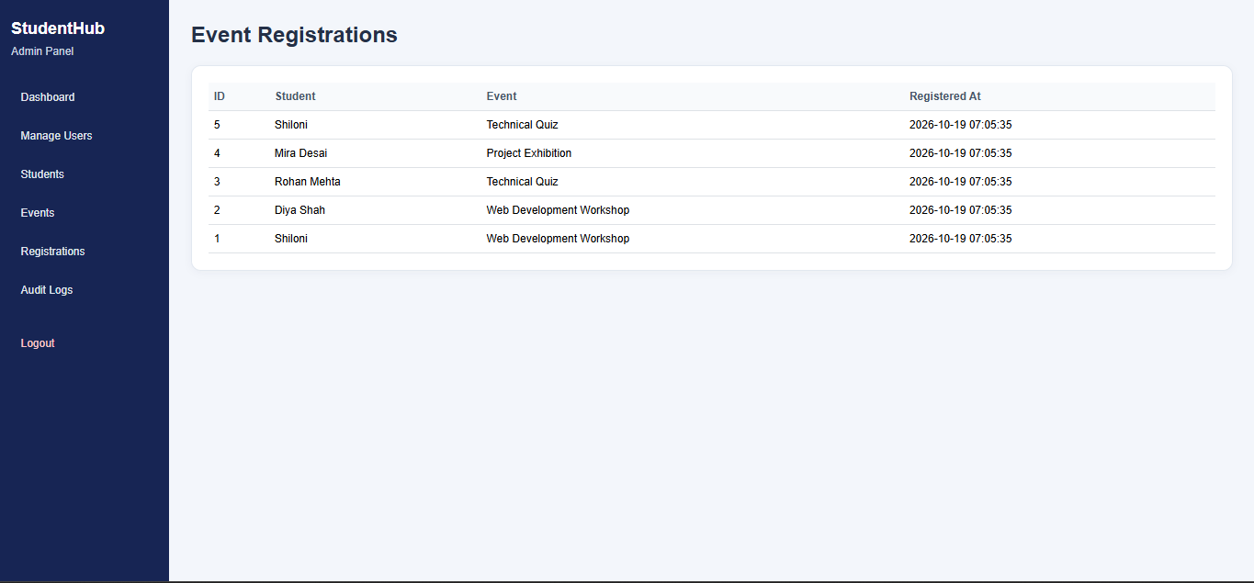

Audit logs:
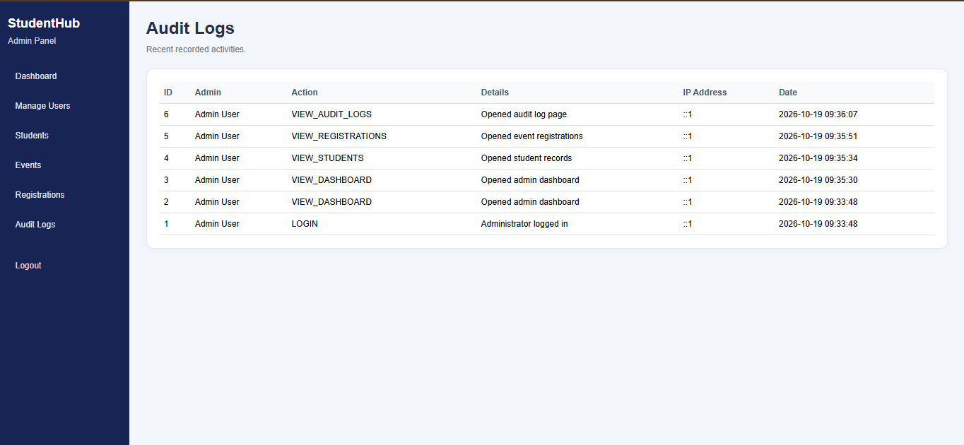

Database:
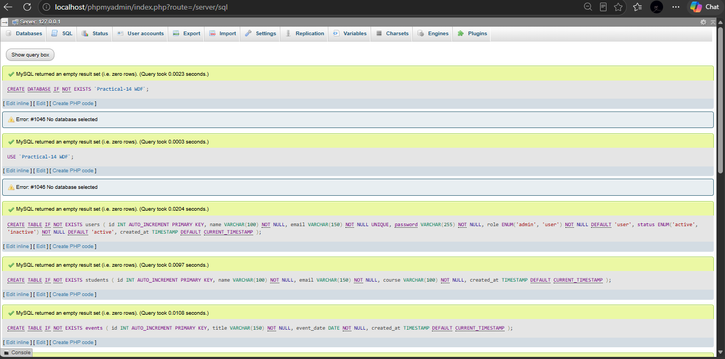
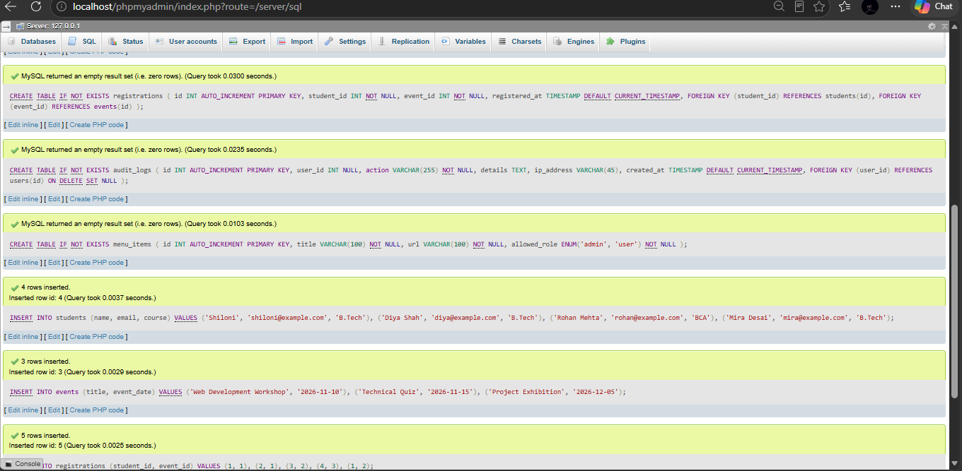
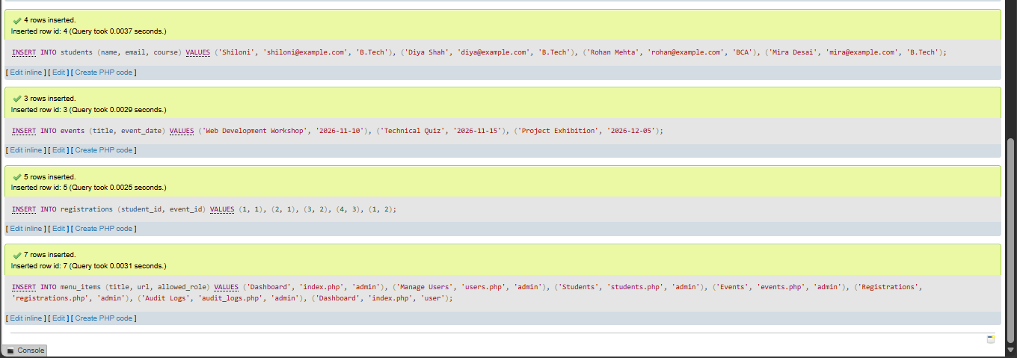

Table in MYSQL:
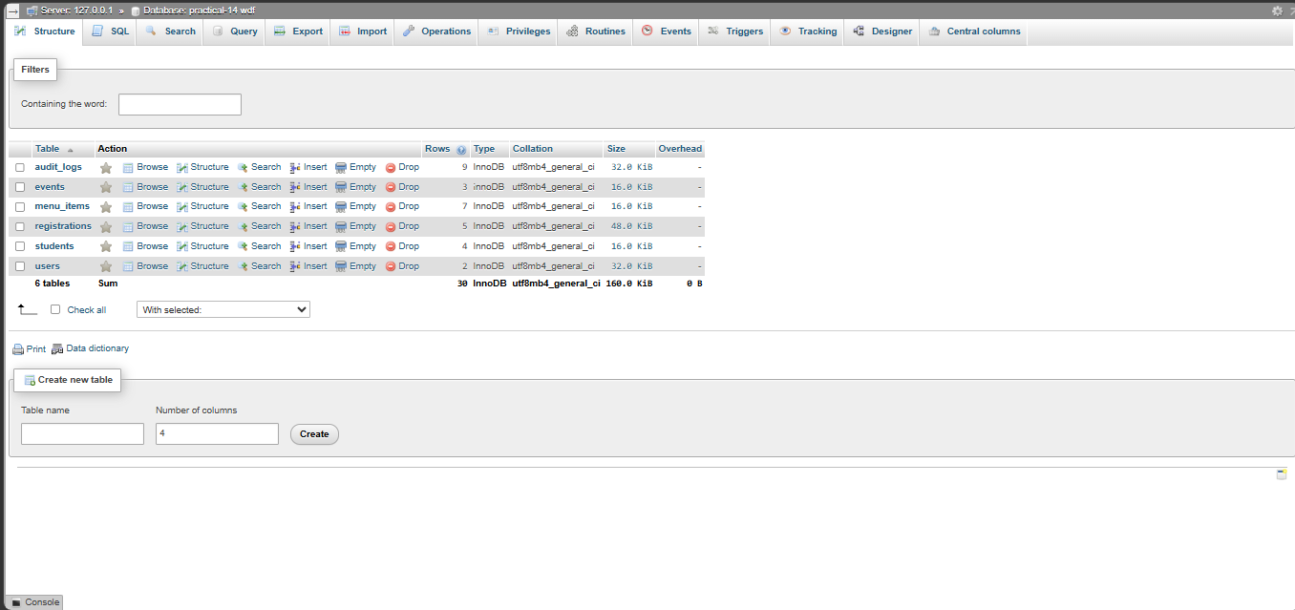

GitHub Repository Link:

https://github.com/shiloni28/WDF.git

E.Challenges Faced:

- Firstly it was not correctly connected and thus the error of 404 was seen.
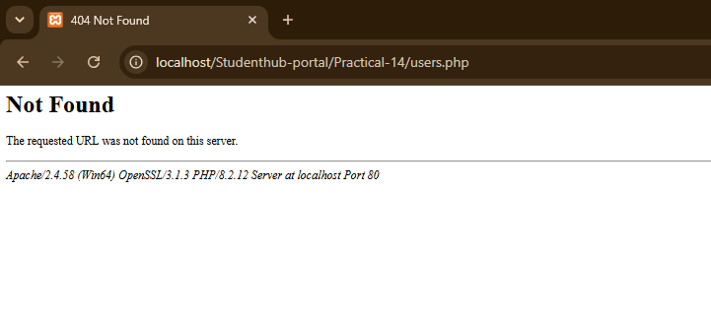

- Connecting PHP with the MySQL database using the correct database credentials.
- Creating and importing the required database tables.
- Retrieving dashboard statistics dynamically using SQL queries.
- Implementing role-based access control to restrict the dashboard to administrators.
- Loading menu options dynamically according to the user's role.
- Troubleshooting PHP errors and verifying the correct output in the browser.
- Ensuring that the dashboard displays the latest registrations and accurate counts.

F.Learning Outcomes:

- Develop an admin dashboard using PHP, MySQL, HTML, CSS, and Bootstrap.
- Connect a PHP application to a MySQL database.
- Retrieve and display dashboard statistics using SQL queries.
- Implement authentication and role-based access control.
- Create a dynamic navigation menu based on user roles.
- Record and display important activities using an audit log.
- Display student details, event information, and recent registrations.
- Test application functionality and troubleshoot database or PHP errors.
- Understand the importance of secure access to administrative pages.
- To restrict the different users and only allowing the admin to access it.

Faculty Remarks:

